Write a formal definition of the classification problem. Explain the classification problem from credit scoring data with low-risk and high-risk customers.

The classification problem is a type of supervised learning task in which the goal is to predict the categorical label or class of a given input based on its features. In the context of credit scoring, the classification problem involves assigning customers to either a low-risk or high-risk category based on various financial and demographic features, such as income, credit history, employment status, and debt levels. The objective is to accurately predict whether a customer is likely to default on a loan (high-risk) or repay it (low-risk), which helps financial institutions in making informed lending decisions.

Illustrations of Different VC Dimensions:
- VC Dimension 1:
  - Consider a line in 1D space. If you have two points, you can place a threshold such that the line classifies all points correctly. However, with three points, there’s no way to classify all of them in every possible configuration. Thus, the VC dimension of a threshold classifier in 1D space is 1.
- VC Dimension 2:
  - For a straight line in 2D space, any two points can be separated, and three points can usually be separated if they are not collinear. However, four points in 2D space cannot always be separated by a single straight line in all possible configurations. Hence, a straight line in 2D has a VC dimension of 3.
- VC Dimension N:
  - In general, for an N-dimensional space, the VC dimension is usually N+1 for linear classifiers.
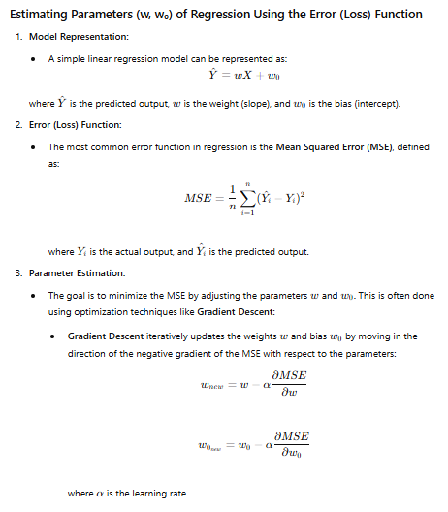

Define machine learning with different kinds of scenarios.
Machine learning is a branch of artificial intelligence (AI) where systems learn from data to make predictions or decisions without being explicitly programmed. Here are a few scenarios that illustrate different types of machine learning:

1. **Supervised Learning**: Supervised learning is a type of machine learning where a model is trained on labeled data to make predictions or classify new, unseen data.

2. **Unsupervised Learning**: Unsupervised learning is a type of machine learning where the model learns patterns from unlabeled data without explicit guidance on what to predict.

3. **Reinforcement Learning**: Reinforcement Learning is a type of machine learning where an agent learns to make decisions by receiving rewards or penalties for its actions, aiming to maximize cumulative rewards over time.

4. **Semi-supervised Learning**: Semi-supervised learning is a machine learning approach that combines a small amount of labeled data with a larger amount of unlabeled data to improve learning accuracy.

5.**Transfer Learning**: Transfer learning is a machine learning technique where a model trained on one task is reused or fine-tuned on a different but related task.

What is market basket analysis? How to determine the purchased trend using the association rule?
**Market Basket Analysis** is a data mining technique used to identify relationships between items frequently bought together in transactions. It's commonly used in retail to understand customer purchasing behavior and optimize marketing strategies.

To determine purchase trends using the **association rule**:

1. **Identify frequent itemsets**: These are groups of items that frequently appear together in transactions (e.g., {bread, butter}).

2. **Generate association rules**: From these itemsets, create rules of the form "If X, then Y" (e.g., "If a customer buys bread, they are likely to buy butter").

3. **Measure the rules' strength**:
- **Support**: The proportion of transactions that contain both X and Y.
- **Confidence**: The likelihood that Y is purchased when X is purchased.
- **Lift**: The ratio of the observed support to that expected if X and Y were independent.

By analyzing these metrics, you can uncover patterns and trends in customer purchases, helping to make informed decisions about product placement, promotions, and inventory management.

Define VC dimension with different scenarios.

What is a Bayesian classifier? Derive a Bayesian classification model where Bayes' classifier chooses the class with the highest posterior probability.

A Bayesian classifier is a probabilistic model that uses Bayes' theorem to classify data based on prior knowledge and observed evidence.
